**Class B Audio Amplifier Project**

using a complementary push-pull transistor configuration

**Team Members:**

Menna Elrahman Mohamed

Hany Ehab

Tasneem Abdelrahman

**Under supervision:**

Dr / mostafa wageeh

Dr / Mohammed tawheed

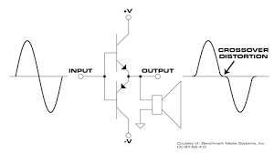

**Abstract:**

This project presents the development of a **Class B audio amplifier** designed to efficiently amplify analog signals using a push-pull transistor configuration. Class B amplifiers are widely used in audio applications due to their high efficiency, which is achieved by activating each transistor for only one half of the input waveform.

The amplifier circuit employs **complementary NPN and PNP transistors (TIP31 and TIP32)** to handle the positive and negative halves of the waveform, along with supporting components such as resistors and capacitors for signal conditioning and stability.

**Introduction:**

Amplifiers are fundamental components in electronics, used to increase the amplitude of electrical signals for various applications ranging from communication systems to audio devices. They are classified into different classes—A, B, AB, C, and others—based on how the output devices (transistors) conduct during a signal cycle.

This project centers around the **Class B amplifier**, which is known for its high efficiency and relatively simple design. Unlike Class A amplifiers, where the output device conducts throughout the entire input cycle, Class B amplifiers use two complementary transistors—one handling the positive half of the input signal and the other handling the negative half. This **push-pull configuration** allows for significant power savings and reduced heat generation.

However, Class B amplifiers come with a notable drawback: **crossover distortion**, which occurs around the zero-crossing point of the signal where neither transistor conducts fully. This issue affects audio quality, especially in low-amplitude signals.

**Circuit Configuration:**

The Class B amplifier used in this project is built around a **push-pull configuration** that employs two complementary transistors — **TIP31 (NPN)** and **TIP32 (PNP)**. These transistors work alternately to amplify different halves of the input signal: TIP31 handles the positive half, while TIP32 handles the negative half.

To ensure stable operation, the circuit includes **resistors** for current limiting and biasing, and **capacitors** for input and output coupling as well as filtering. A **0.5-ohm resistor** is used in series with each emitter to help balance the current and reduce crossover distortion. The power supply used is typically 12V DC, and the output is connected to a speaker load for testing.

**Working principle:**

In a Class B amplifier, the input signal is split into **two half-cycles**:

* The **positive half** is amplified by the NPN transistor.
* The **negative half** is amplified by the PNP transistor.

This division of labor between the two transistors reduces the amount of time each transistor is active, which in turn **reduces power consumption** and **heat generation** compared to Class A amplifiers.

However, without biasing, both transistors are off during the transition near **zero volts**, causing distortion. To overcome this, the circuit can be biased slightly so that both transistors are slightly conducting near zero, effectively turning it into a **hybrid** between **class B and Class AB** configuration for better linearity.

**Crossover Distortion:**

**Crossover distortion** is a major drawback of pure Class B amplifiers. It occurs when the signal transitions through the zero-voltage point, and neither transistor is conducting for a brief moment. This results in a **notch** or **gap** in the output waveform, especially noticeable in audio applications.

To reduce this distortion:

* A **small bias voltage** is applied between the base-emitter junctions of the transistors.
* **Emitter resistors** are used to provide local negative feedback, helping balance the conduction and smooth the signal.

**Advantages and Disadvantages:**

Advantages:

* High Efficiency (up to 78.5%) compared to Class A.
* Reduced Power Loss, since each transistor conducts for only half the cycle.
* Lower Heat Generation, reducing the need for heavy heatsinks.

Disadvantages:

* Crossover Distortion affects audio fidelity.
* Complex Biasing Requirements to reduce distortion.
* More Complex Design compared to Class A, especially if adding feedback or filters.

**Components:**

Transistor (NPN / PNP)

---> Amplifies positive and negative half of the input signal

Voltage divider

---> divide the Vcc voltage to suit the amplifier circuit

Biasing resistance

---> keep the **class B** transistors in the active region

**DC analysis:**

Rth = 10 / (22k + 10k) = .3125Ω

Vth = Vcc * Rth = 12 × .3125 = 3.75V

VE = Vth - VBE = 3.75V - 0.7V = 3.05V

IE = VE / RE = 3.05 / 330 = 9.24 mA

Assuming β = 100 for 2N3904:

α = β / (β + 1) = 100 / 101

→ IC ≈ α × IE

→ IB = IE - IC = 9.24 mA - 9.15 mA = 0.09 mA

→ KVL:

12 - (9.15×10⁻³ × 390) - VCE - (9.24×10⁻³ × 330) = 0

→ VCE = 5.38V

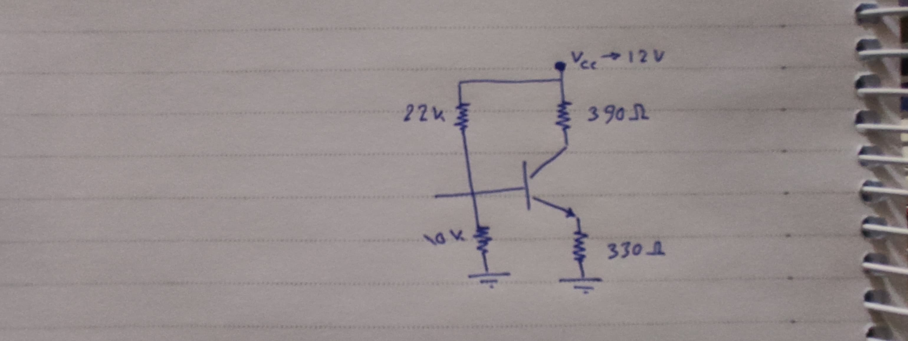→ VCE > 0.7 → transistor in Active region

**AC analysis:**

rπ = β / gm → gm = Ic / VT = 9.15 × 10^-3 / 25 × 10^-3 = 0.366 S

rπ = 100 / 0.366 = 273.22 Ω

Rin = (1/10k + 1/22k + 1/273.22)^-1 = 262.78 Ω

ib = Vin / Rin = 0.2 / 262.78 = 7.611 × 10^-4 A

ic = β * ib = 7.61 × 10^-4 × 100 = 76.1 mA

Vout = -ic × Rc = -76.1 × 390 × 10^-3 = -29.679 V

Av = -gm * Rc = -0.366 * 390 = -142.74

**References:**

* ELECTRONIC DEVICES Electron Flow Version Ninth Edition (Thomas L. Floyd)
* Sedra & Smith, *Microelectronic Circuits* seventh edition.
* Project Simulation and Team Research Documentation.
* Doctors lectures and sections